Florida Veterans Foundation
Fiscal Year 25-26 – 4th Quarter Report
(April 2026 – June 2026)

Florida Veterans Foundation (FVF)
The Foundation operates for the direct and indirect benefit of the FDVA, Veterans of Florida, and the state Veteran’s Service Organizations (VSO). FVF is a 501(C)(3) nonprofit operating for charitable and educational purposes. The Foundation operates utilizing appropriated funds, grants, and donations. The Foundation has three full-time contracted employees.

Board of Directors and Community Partners
Our board of directors and partners donate time and resources to support the mission of FVF and its programs.

FVF Outreach Metrics
Metrics | First Quarter Reach | Second Quarter Reach | Third Quarter Reach | Fourth Quarter Reach | FY 25-26 Totals - YTD
Facebook Reach | 11,554 | 12,120 | 15,990 | 50,574 | 90,238
Twitter Followers | 318 | 320 | 325 | 327 | 1290
Instagram Page Followers | 162 | 177 | 194 | 1,112 (35,924 views) | 1645
LinkedIn Page Followers | 1482 | 1,528 | 1,588 | 1,715 | 6313
Website Page Views | 16,695 | 11,051 | 15,694 | 16,767 | 60,207

Fundraising & Donations
Grant/Donation  Type | First  Quarter | Second  Quarter | Third  Quarter | Fourth  Quarter | FY 25-26  Totals - YTD
Corporate / Bus. Grants | $2,182.79 | $13,632.41 | $317.79 | 0 | $16,132.99
Direct Public Support | $3,015.01 | $1,960.40 | $1,228.50 | $664.370.00 | $6,868.28
Government Contracts | $101,035.00 | $335,426.21 | $292,786.59 | $372,484.00 | $1,101,731.80
Special Events | $0 | $8,018.87 | $0 | $1,500.00 | $9,518.87
Miscellaneous Revenue/License Plate | $533,875.66 | $334,700.00 | $336,700.00 | $310,575.0 | $1,515,850.66
Total | $640,108.46 | $693,737.89 | $631,032.88 | 1,348,929.00 | $3,313,808.23

Veterans Dental Grant Program
Four 501(C)(3) Providers have been awarded grants in FY 2025-2026. Overall grant spend for the year is $1,641,339.07. Veteran satisfaction is 100% and Awardees are all in compliance with program guidelines. This program has significantly impacted on the quality of life for the veterans that have been served.

Florida Veterans Dental Program
Veterans Dental Grant Program | First  Quarter | Second  Quarter | Third  Quarter | Fourth  Quarter | FY 25-26  Totals- YTD
Veterans Served | 245 | 304 | 382 | 461 | 1392
Spend | $335,426.21 | $292,786.59 | $372,568.45 | $640,557.82 | $1,641,339.07
Procedures | 1632 | 1579 | 1766 | 2622 | 7663
Veteran Satisfaction | 100% | 100% | 100% | 100% | 100%

Veterans Assistance
American Legion Project Vet Relief | Veterans Museum
Veterans Dental Grant | Veterans Treatment Court Grant
Emergency Referral Services | Veterans Recognition Awards
Operation Noble Endeavors | Emergency Shelter Assistance
Veterans Nursing Home Dental | Emergency Food Assistance
Mission of Mercy (Dental) | Emergency Utility Assistance

Gadsden Flag License Plate Impact on Veteran Services

Veterans Nursing Home Dental Initiative
Funding from the license plate has allowed the FVF to fund a pilot program to provide dental care on a case-by-case basis for 275 veterans that reside in the Florida Veterans’ Nursing homes and domiciliary.

Project Vet Relief
The Florida Veterans Foundation provides $15,000 each month to Project Vet Relief to support veterans in crisis across the state. This funding helps deliver immediate financial assistance for essentials like housing, utilities, and food, ensuring that veterans facing hardship can stabilize quickly. Through this partnership, the foundation plays a critical role in preventing homelessness and supporting the well-being of Florida’s veteran community.

Honor Flight: Heroes to Washington Grant
The Florida Veterans Foundation (FVF) partners with Honor Flight hubs across Florida to support their mission of transporting veterans to Washington, D.C. to visit their memorials. Through this partnership, FVF provides $15,000 in support to each of 10 Honor Flight hubs, helping offset operational costs and ensuring more veterans can participate in these meaningful trips. This investment strengthens statewide collaboration in honoring and serving Florida’s veterans with dignity and gratitude.

Veterans Museum History Program
The Florida Veterans Foundation’s partnership with the Veterans Museum helps preserve and share the stories, history, and sacrifices of Florida’s service members. Through collaboration and support, FVF helps enhance educational programming, exhibits, and outreach efforts that honor veterans across generations. This partnership ensures that veterans’ experiences are not only remembered but actively shared with the public.

FVF Non-Profit Grants
The Florida Veterans Foundation’s grant program provides funding to Florida's veteran-serving organizations to address needs that may not be covered by larger funding sources. These grants help support critical gaps such as outreach efforts and local veteran assistance initiatives.

Operation Noble Endeavors
The foundation began the Noble Endeavors Initiative, supporting programs that promote long-term stability and well-being for veterans in Florida’s State Veterans’ Nursing Homes. The partnership remains an important part of the Foundation’s broader mission to address unmet needs within the veteran community through innovative and sustainable solutions.

Mission of Mercy
The Florida Veterans Foundation proudly provides an annual $25,000.00 grant to support the Mission of Mercy dental event, which is hosted in a different Florida community each year. In addition to providing financial support, Foundation staff participate in the event to help ensure veterans receive priority access to dental care on the first day. This partnership enables volunteer dental professionals to provide essential services to veterans who may otherwise be unable to afford treatment.

Organizational Recognition

Pillars of Excellence
The Florida Veterans Foundation is proud to be the Florida Department of Veterans’ Affairs' nominee for the NASDVA National Pillars of Excellence Award. Our submission highlights our commitment to veteran health through the Florida Veterans Dental Grant Program and our dedicated dental care initiatives for residents of State Nursing Homes.

FVF Non-Profit Ratings
The Foundation has now received three certifications from national non-profit entities, 1) GuideStar Gold Candid Transparency Seal 2) Charity Navigator 4-Star Rating and 3) Great Non-Profits Top-Rated Seal.

FLORIDA VETERAN’S FOUNDATION IN ACTION

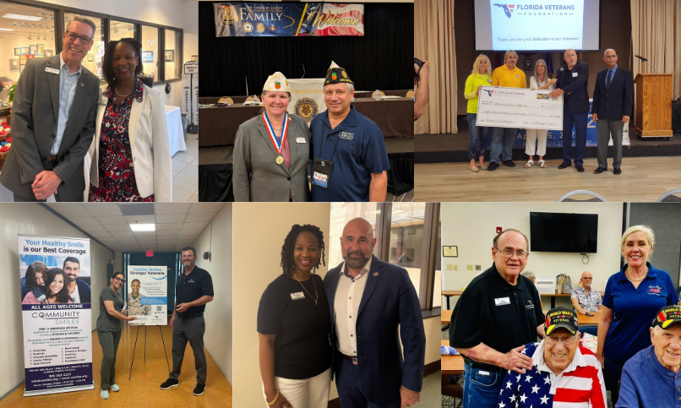

Board and Staff Participated in the Following Events
for the 4th Quarter FY 25-26

Fourth Quarter Events
Executive Board Meetings | Community Smiles/WVRF On-Site Visits | American Legion Department of Florida Annual Convention
11th Annual FLHSMV Veterans Recognition Day | Florida Veterans Council | Veterans Recognition Events
Honor Flight Check Presentations | 2026 4th of July  Heroes Boat Parade | The Veterans Legacy  Tribute Event
Mission of Mercy Veterans Dental Event | 2026 Hero Fest | Flagler Chapter NSDAR Dinner Dance Gala

Acknowledgement: FVF is grateful for FDVA’s partnership through the provisions of office space, administrative and legal collaboration efforts that helps to support FVF mission objectives.

